Project on SQL By Using MYSQL – Company Job Data

1. What is the average salary for all the jobs in the dataset?



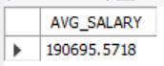

1. What is the highest salary in the dataset and which job role does it correspond to?

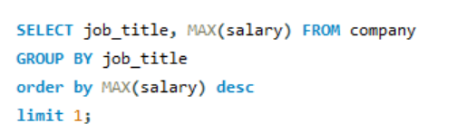

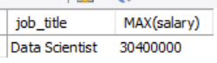

1. What is the average salary for data scientists in US?

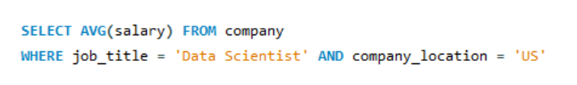

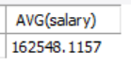

1. What is the number of jobs available for each job title?

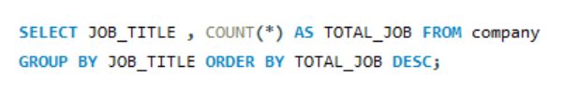

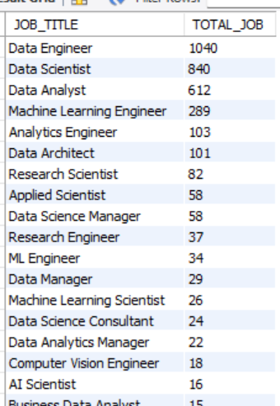

1. What is the total salary paid for all data analyst jobs in DE?

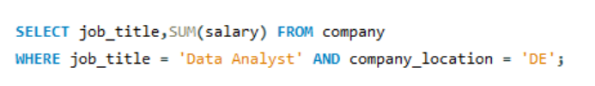

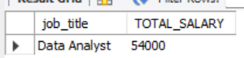

1. What are the top 5 highest paying job titles and their corresponding average salaries?

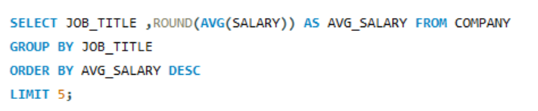

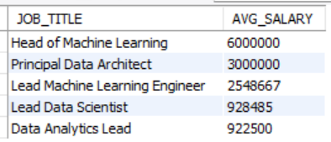

1. What is the number of jobs available in each location?

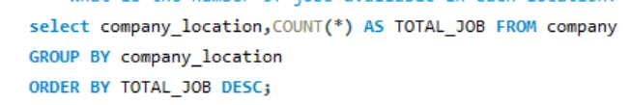

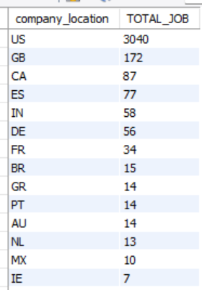

1. What are the top 3 job titles that have the most jobs available in the dataset?

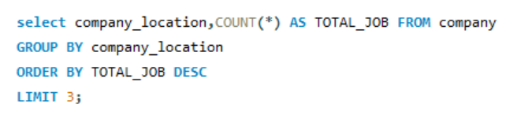

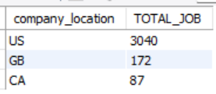

1. What is the average salary for data engineers in Boston?

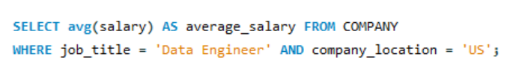

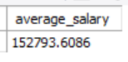

1. What are the top 5 cities with the highest average salaries?

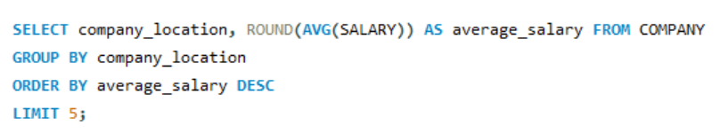

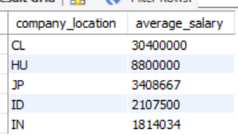

1. What is the average salary for each job title, and what is the total number of jobs available for each job title?

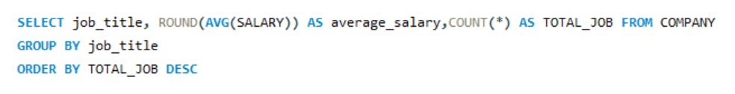

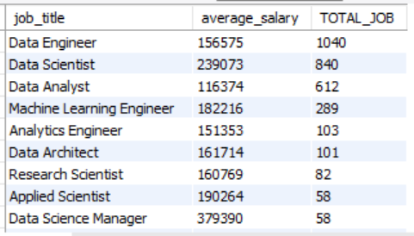

1. What are the top 5 job titles with the highest total salaries, and what is the total number of jobs available for each job title?

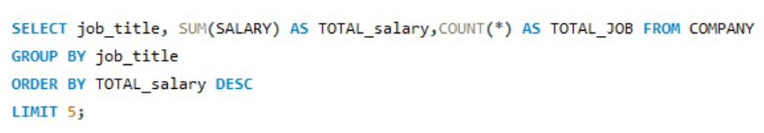

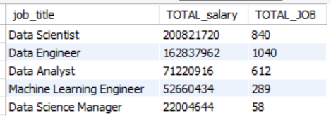

1. What are the top 5 locations with the highest total salaries, and what is the total number of jobs available for each location?

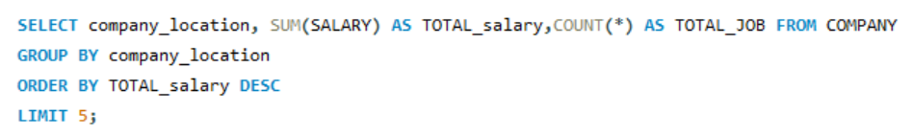

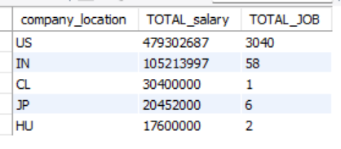

1. What is the average salary for each job title in each location, and what is the total number of jobs available for each job title in each location?

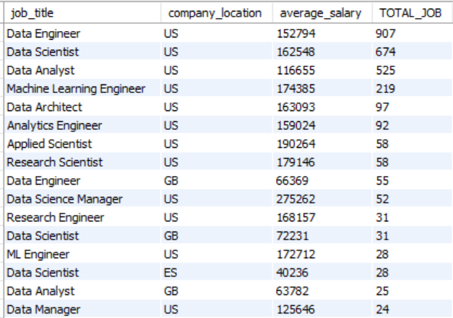

1. What is the average salary for each job title in each location, and what is the percentage of jobs for each job title in each location?

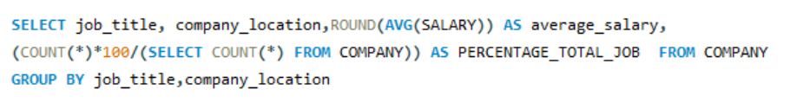

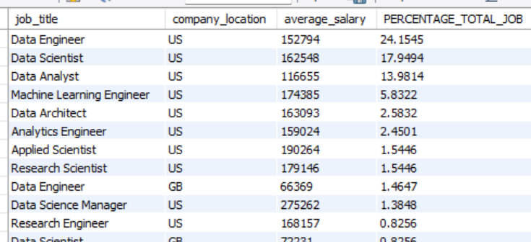

1. What are the top 5 job titles with the highest average salaries, and what is the total number of jobs available for each job title?

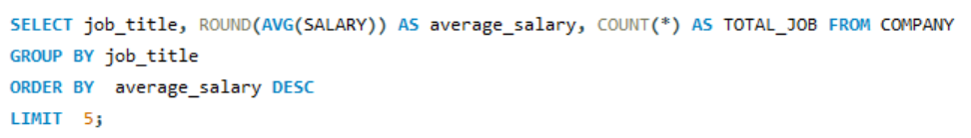

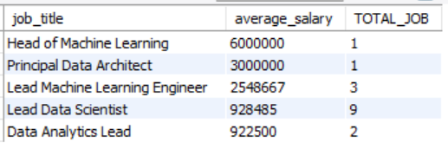

1. What is the average salary for each job title, and what is the percentage of jobs for each job title in the dataset?

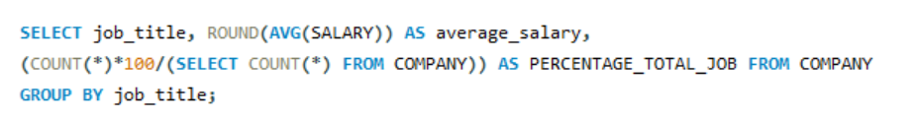

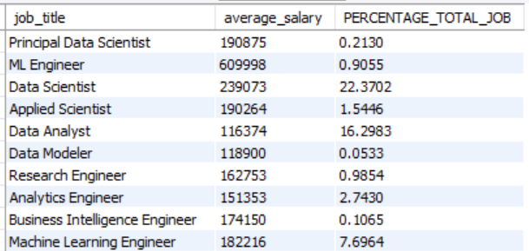

1. What is the total number of jobs available for each year of experience, and what is the average salary for each year of experience?



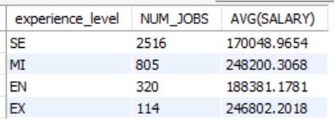

1. What is the average salary for each experience level, and what is the total number of jobs available for each degree level?



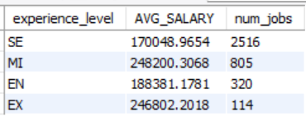

1. What are the top 5 job titles with the highest salaries, and what is the name of the company that offers the highest salary for each job title?

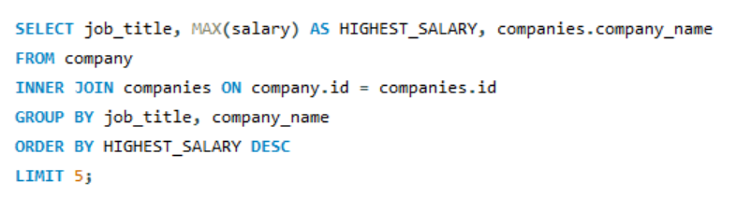

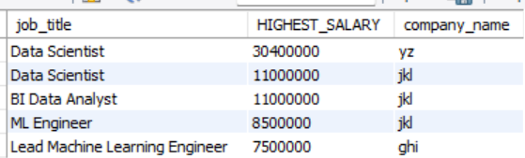

1. What is the total number of jobs available for each job title, and what is the name of the company that offers the highest salary for each job title?

